JMETER INSTALLATION GUIDE

Project Name | Risk Master Application Performance Analysis

Prepared By | Date of Preparation
Kumud Naithani | June 14, 2016
Reviewed by | Date of Review
Mahendra Pratap Singh | October 16, 2016
Version Number | Version Change Date
0.01 D | October 14, 2016
Modified By | Modification Info

Contents
JMETER INSTALLATION GUIDE 1
1 Introduction: 3
1.1 Purpose: 3
2 JMeter Tool: 3
2.1 Introduction To JMeter Tool: 3
2.2 Protocols Supported By JMeter Tool: 3
2.3 Advantages Of JMeter Tool: 4
2.4 JMeter Tool Work Flow: 5
3 Steps To Install Java Development Kit: 6
3.1 Introduction To Java Development Kit: 6
3.2 Steps To Install Java Development Kit: 6
3.3 Steps To Configure Java Development Kit: 10
4 Steps To Install JMeter: 13
4.1 Steps To Install JMeter: 13
5 Steps To Install JMeter: 15
5.1 Start JMeter In GUI Mode: 15
5.2 Start JMeter In Server Mode: 17
5.3 Start JMeter In Command Line Mode: 19
6 Required JMeter Property Changes: 20
6.1 Property File Changes: 20
6.2 Batch File Changes: 21
7 Revision History Of The Work Product: 22

Introduction:

Purpose:

This document provides an insight on to the detailed steps required to setup JMeter Performance Test tool on the user machine on Windows platform as well as its usage. It includes installation steps for:
- Java Development Kit (JDK) which includes Java Run-time environment (JRE), Java Virtual Machine (JVM) and Java Compiler
- JMeter Tool

JMeter Tool:

Introduction To JMeter Tool:
- The Apache JMeter is pure Java open source software, which was first developed by Stefano Mazzocchi. It is designed to load test functional behavior and measure performance. It was originally designed for testing Web Applications but has since expanded to other test functions.
- It is used used to test performance both on static and dynamic resources (Web Services (SOAP/REST), Web dynamic languages - PHP, Java, ASP.NET, Files, etc. -, Java Objects, Data Bases and Queries, FTP Servers and more). It can be used to simulate a heavy load on a server, group of servers, network or object to test its strength or to analyze overall performance under different load types.
- It is a Java desktop application with a graphical interface that uses the Swing graphical API. It can therefore run on any environment / workstation that accepts a Java virtual machine, for example − Windows, Linux, Mac, etc.

Protocols Supported By JMeter Tool:
- Web − HTTP, HTTPS sites 'web 1.0' web 2.0 (ajax, flex and flex-ws-amf)
- Web Services − SOAP / XML-RPC
- Database via JDBC drivers
- Directory – LDAP
- Mail − POP3, IMAP, SMTP
- FTP Service
- Messaging Oriented Middleware (MOM) via JMS
- Native commands or shell scripts
- TCP

Advantages Of JMeter Tool:
- Open source license, Simple, Intuitive & Friendly GUI: JMeter is totally free, even allow developers to use source code for development. Careful GUI design allows faster Test Plan building and debugging
- Full multi-threading framework. JMeter allows concurrent and simultaneous sampling of different functions by a separate thread group
- Support multi-protocol: JMeter does not only support web application testing, but also evaluate database server performance. All basic protocols such as HTTP,JDBC, LDAP, SOAP, JMS, and FTP are supported by JMeter
- XML Format Test Plan: JMeter stores its test plans in XML format. This means you can generate a test plan using a text editor.
- Multiple testing Strategies: JMeter supports many testing strategies such as Load Testing, Distributed Testing, and Functional Testing.
- Highly Extensible core:

  - Pluggable Samplers allow unlimited testing capabilities

  - Several load statistics may be chosen with pluggable timers.

  - Data analysis and visualization plugins allow great extensibility as well as personalization.

  - Functions can be used to provide dynamic input to a test or provide data manipulation.

  - Scriptable Samplers (Bean Shell, BSF-compatible languages and JSR223-compatible languages)
- Script Test: JMeter can be integrated with Bean Shell & Selenium for automated testing.
- Swing and lightweight component support: Has precompiled JAR uses packages javax.swing.*).
- Record & Playback - Record the user activity on the browser and simulate them in web application using JMeter

JMeter Tool Work Flow:
JMeter simulates a group of users sending requests to a target server, and returns statistics that show the performance/functionality of the target server/application via tables, graphs, etc.
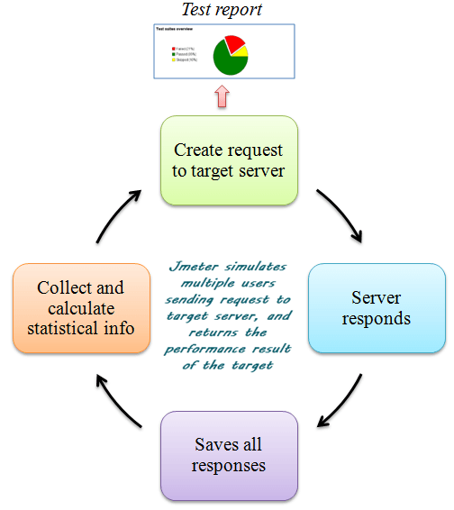

Steps To Install Java Development Kit:

Introduction To Java Development Kit:
Because JMeter is pure Java desktop application, it requires a fully compliant JVM 6 or higher. Hence user first needs to install Java SE Development Kit

- The Java Development Kit (JDK) is an implementation of either one of the Java SE (Standard Edition), Java EE (Enterprise Edition) or Java ME (Mobile Edition) platforms.
- It is released by Oracle Corporation in the form of a binary product aimed at Java developers on Solaris, Linux, Mac OS X or Windows. The JDK includes a private JVM and a few other resources to finish the development of a Java Application.
- Since the introduction of the Java platform, it has been by far the most widely used Software Development Kit (SDK).

Steps To Install Java Development Kit:
- Navigate to Computer→Properties on the user machine→Note whether machine is 32 bit or 64 bit
- Navigate to Google search page on Internet
(Note: Before starting the installation please make sure that the data connection is of good quality to ensure that all downloads are completed uninterrupted
- Type the stated URL on the address bar :
http://www.oracle.com/technetwork/java/javase/downloads/jdk8-downloads-2133151.html
- Accept the Oracle Binary Code License Agreement for Java SE. Click on the link as per your operating system to start the download of Java Development Kit 8u60 (the current version).
(Please refer the screenshot below)

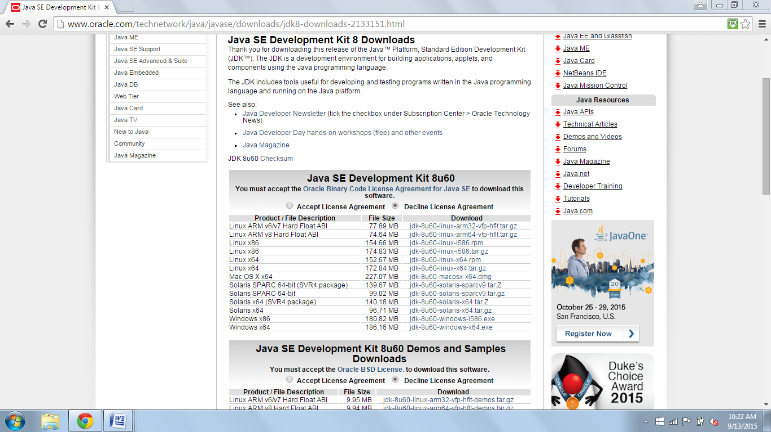

- Click on the second last link if machine is 32 bit. Click on the last Windows download link if machine is 64 bit
- Navigate to the downloaded Java SE Development Kit exe file and run it-->Click on Next button on the opened dialog box (Please refer the below screen shot)

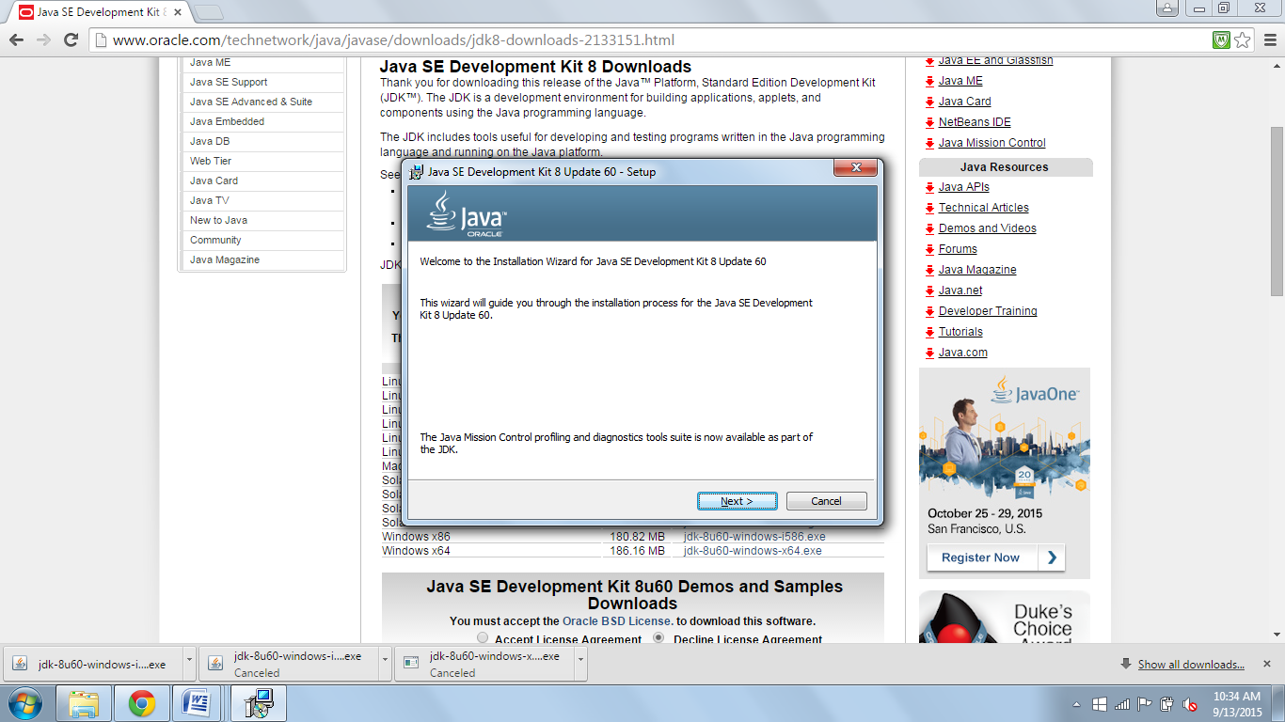

- Click on Next button again on the subsequently opened dialog box. A progress bar as will appear indicating the extraction of the Java Development Kit files
- Once the extraction process is complete a dialog box will be displayed showing the destination folder where Java Development Kit will be placed after installation. Click on Next button displayed on the dialog box (Please refer the screen shot below)

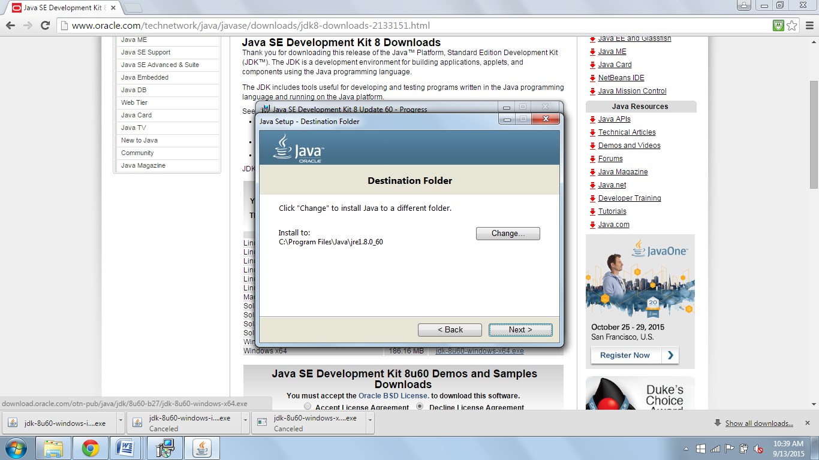

- Installation of Java Development Kit will start and a progress bar will be displayed to indicate the same. Once the installation is complete dialog box as shown in the below screenshot will be displayed. Click on Close button displayed on the dialog box

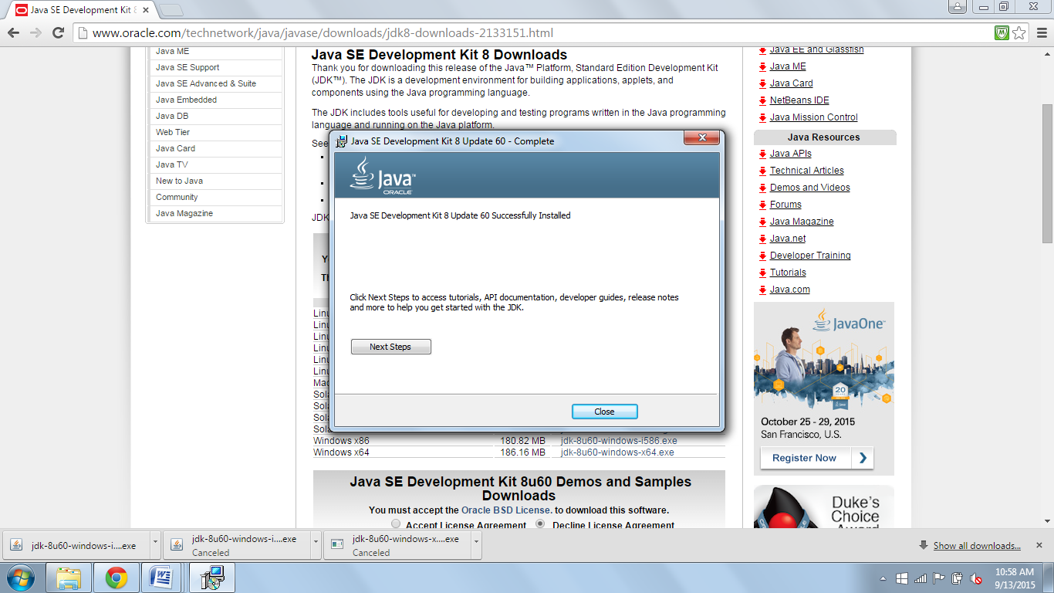

Steps To Configure Java Development Kit:
- Navigate to the following path→C:\Program Files\Java\jdk<version of JDK>\bin→Copy the entire path
- Navigate to Computer→Right click →Select Properties option→Click on Advanced System Settings displayed on the right hand side menu option
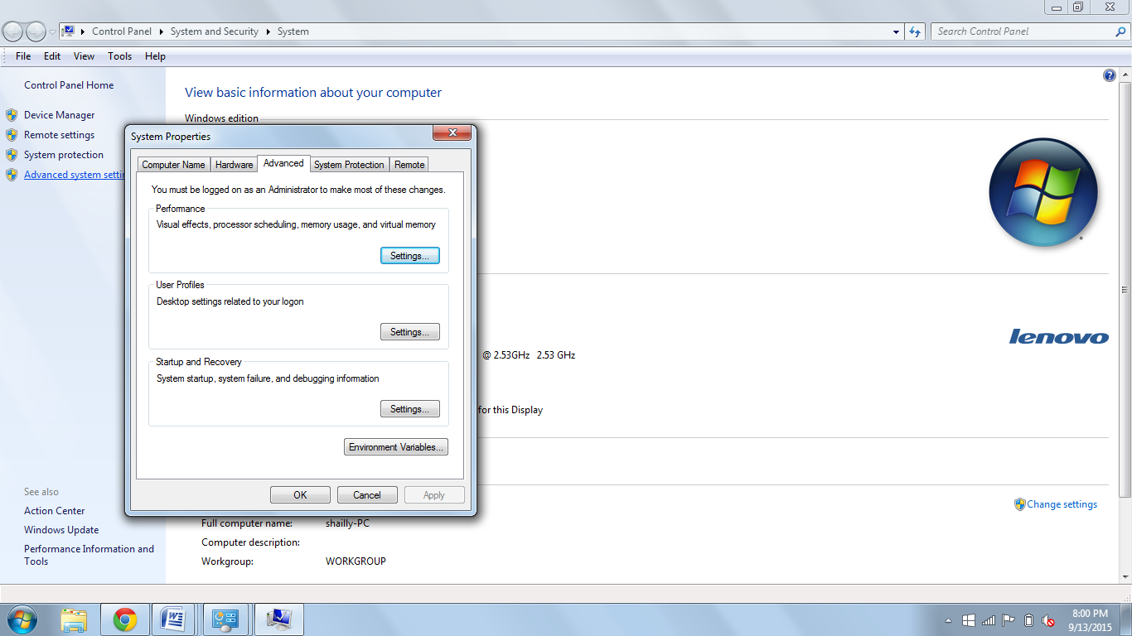

- Click on Environment Variables button→ Navigate to Path system variable→Double click on it to make it editable→Navigate to the end of the path Variable value→Place a semicolon (;)→.After the semicolon paste the copied path (C:\Program Files\Java\jdk<version of JDK>\bin) →(Please refer the screenshot below)
- After that click on OK button on all the three opened dialog box to save the changed “Path” environment variable value

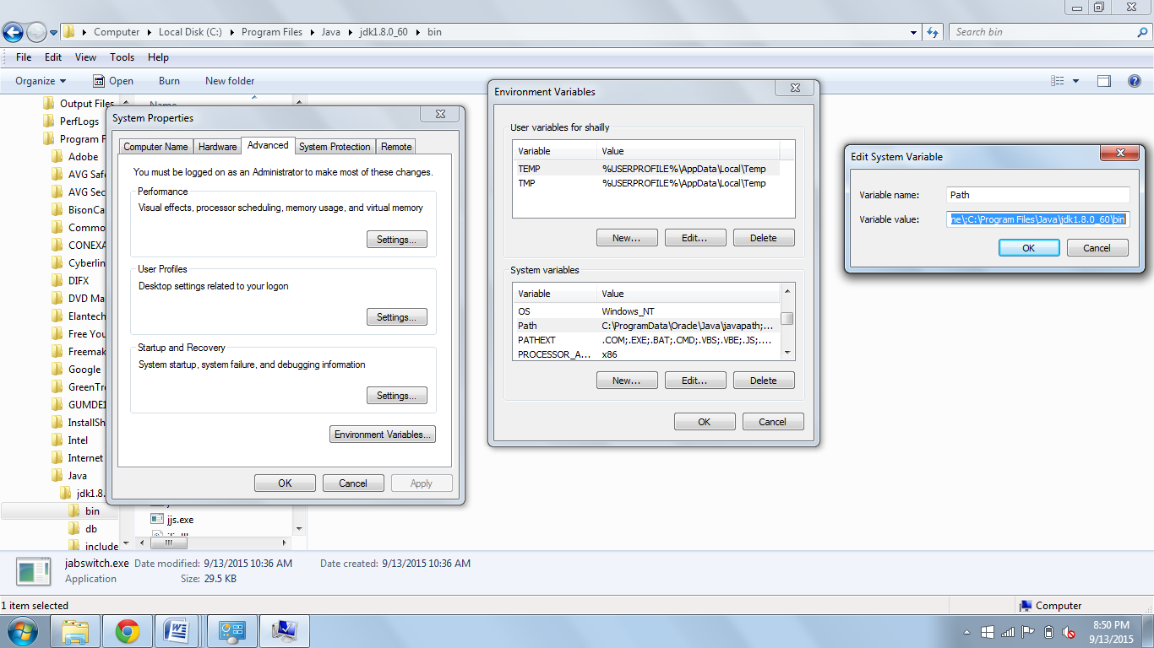

- Write a dummy program as displayed below in Notepad++

class sample
{
public static void main (String []args)
{
System.out.println("Sample Java Program");
}

}

Note: Please copy the program as it is to avoid any syntax and case sensitivity errors. Save the program as sample.java (Select the file type as .java while saving file). Here the program is saved in D:\Java Progs folder

- Run Command Prompt as administrator (cmd.exe)→Type the following commands
- D: (to navigate to D:\ drive)
- cd Java Progs (to change directory to Java Progs folder)
- javac sample.java (to compile the program)
- java sample (to interpret/execute the program)

- Finally the output should be displayed as “Sample Java Program”. (Please refer the screenshot below) Successful execution of the program will indicate the successful installation of the JDK.

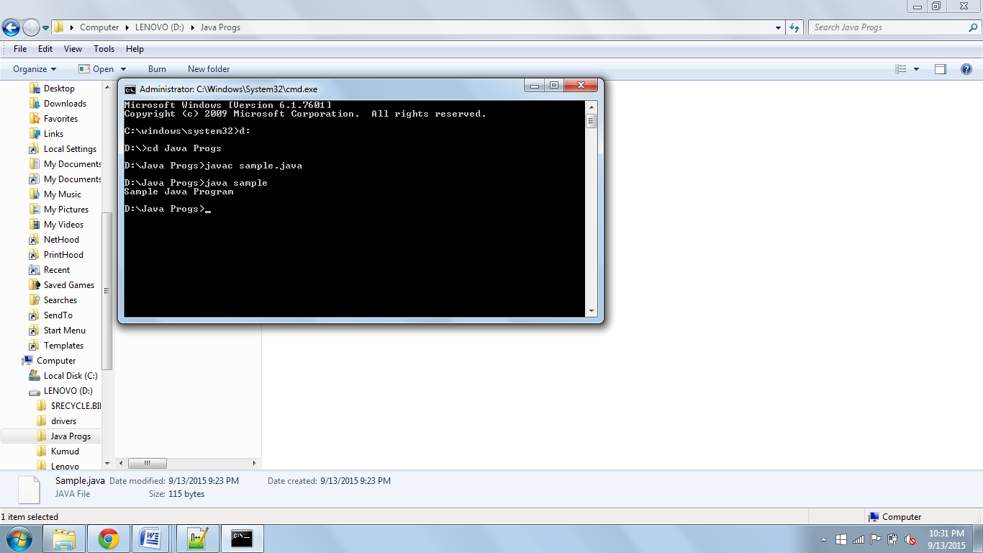

Steps To Install JMeter:

Steps To Install JMeter:
- Navigate to link: “http://jmeter.apache.org/download_jmeter.cgi”. Download the binaries (.zip files) (Please refer the screenshot below)

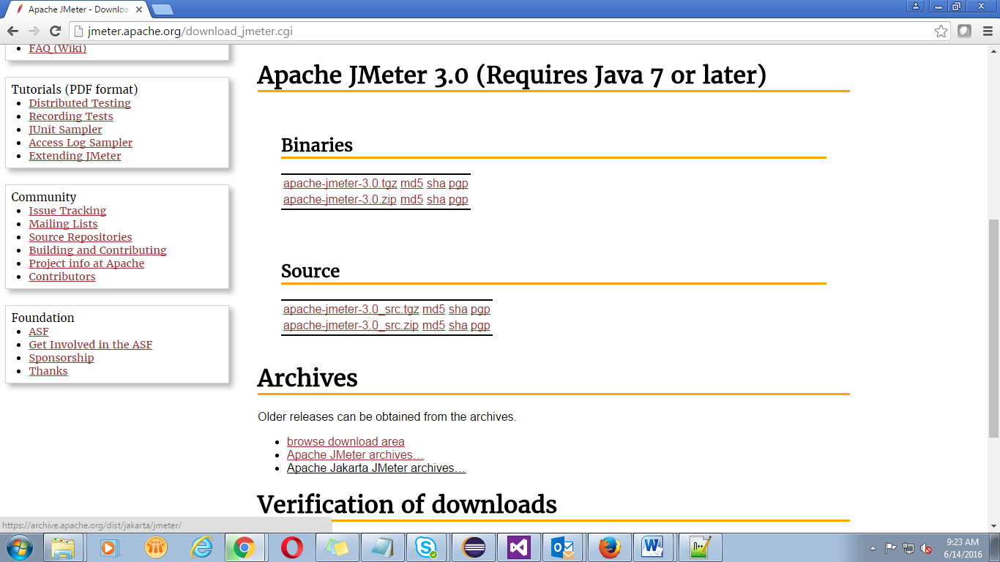

- Copy the JMeter installation downloaded .zip file to the folder wher you want JMeter to be installed. Here .zip file was placed in the following path “C:\JMeter Softwares" and will be referenced further. Unzip the downloaded .zip folder
- Once the unzipping is done installation directory structure should look like as figure below:
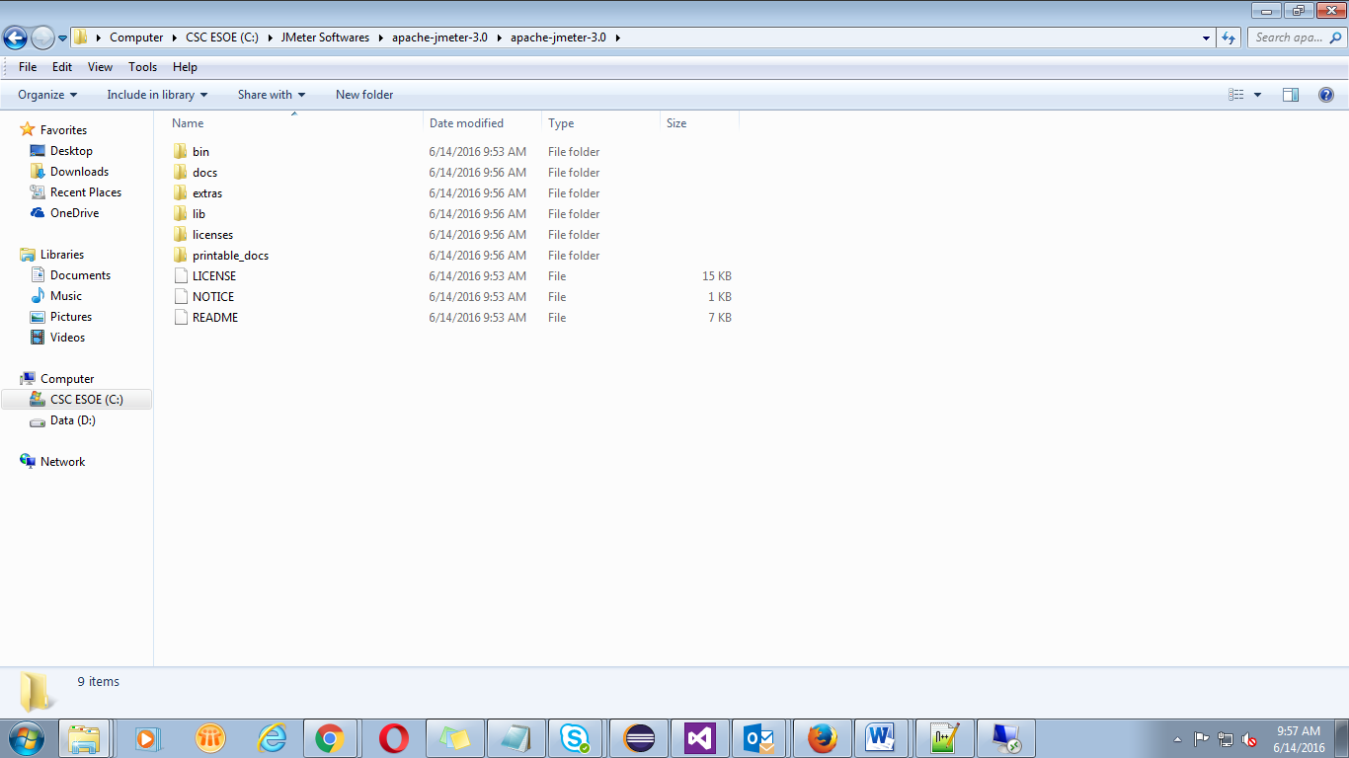

- Description of the JMeter directories and its importance
  - /bin: Contains JMeter script file for starting JMeter
  - /docs: JMeter documentation files
  - /extras: ant related extra files
  - /lib/: Contains the required Java library for JMeter
  - /lib/ext: contains the core jar files for JMeter and the protocols
  - /lib/junit: JUnit library used for JMeter
  - /printable_docs:

Steps To Install JMeter:
- You can start JMeter in 3 modes
- GUI Mode
- Server Mode
- Command Line Mode

Start JMeter In GUI Mode:
- Navigate to path: “C:\JMeter Softwares\apache-jmeter-3.0\apache-jmeter-3.0\bin”
- Select and right click on the following .bat file: “jmeter.bat"→Click on “Run as administrator” option. (Please refer the screenshot below)

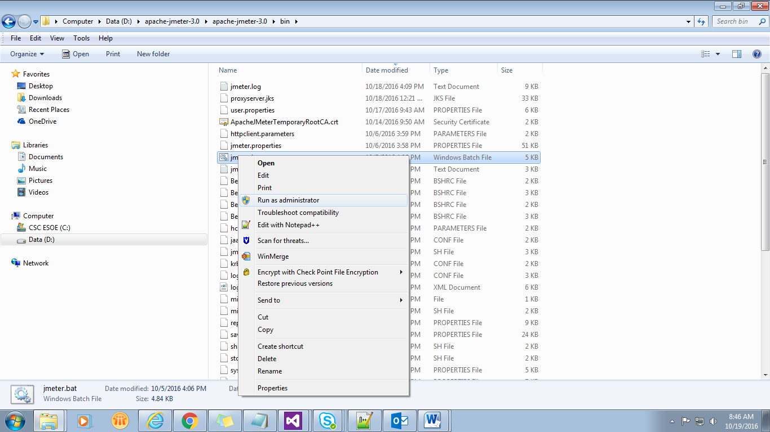
- Initially command line screen will occur with text: “Writing log file to “C:\Windows\System32\jmeter.log” will occur (Please refer the screenshot below)

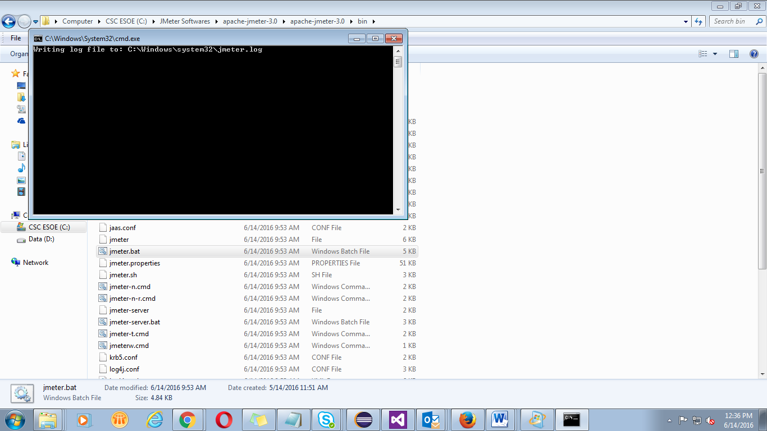

- After that Apace JMeter UI will load. Please refer the screenshot below:

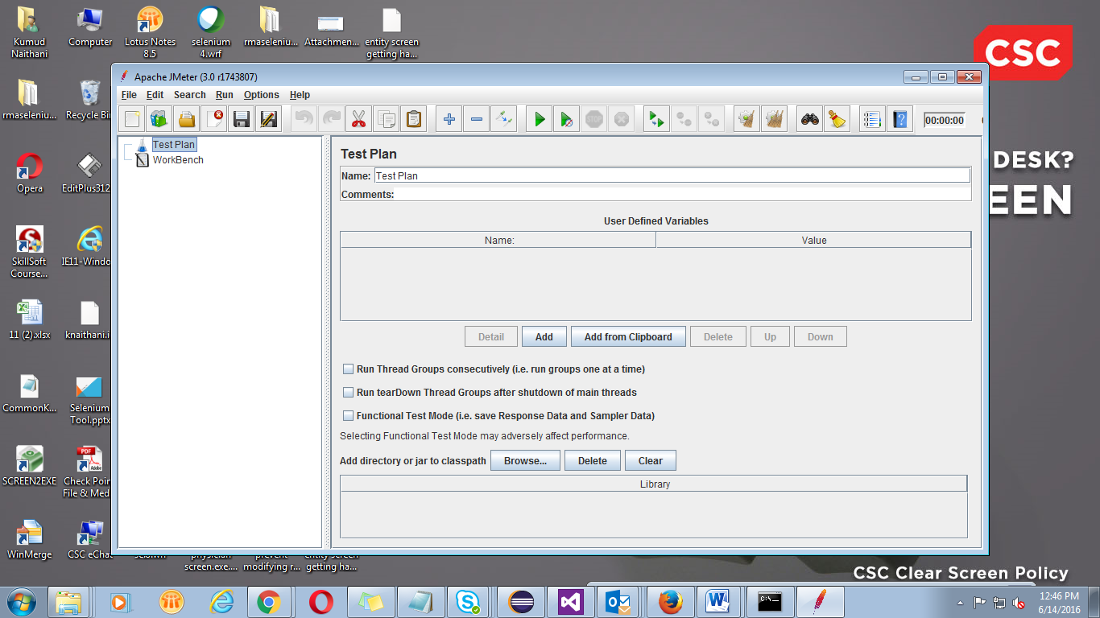

- Following figure annotates the various components in the JMeter GUI

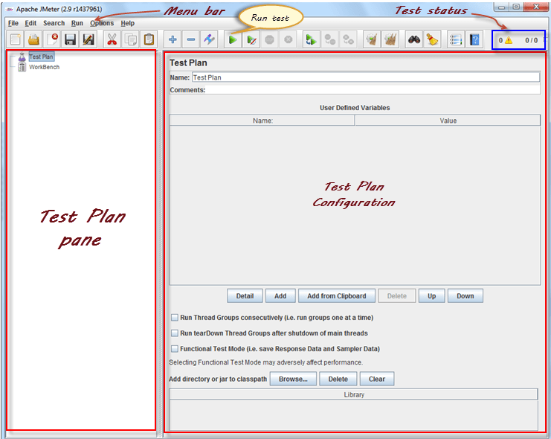

Start JMeter In Server Mode:
- Server mode is used for distributed testing. This testing works as client-server model. In this model, JMeter runs on server computer in server mode. On client computer, JMeter runs in GUI mode.
- Open command line dialog as administrator→Type the following command to run Jmeter in Server mode: “cd <jmeter-server.bat file path>jmeter-server.bat”.
- Here following command was given: “cd C:\JMeter Softwares\apache-jmeter-3.0\apache-jmeter-3.0\bin\jmeter-server.bat". Please refer the screenshot below:

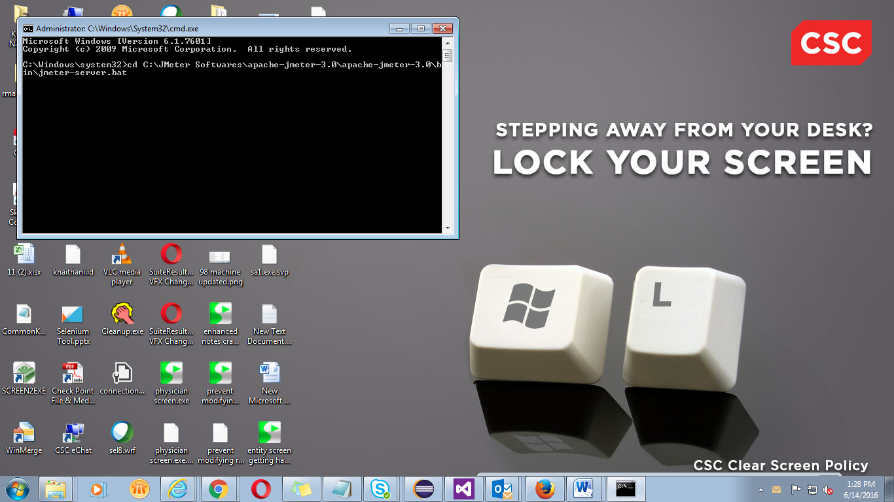

- JMeter should open in server mode. Please refer the screenshot below:

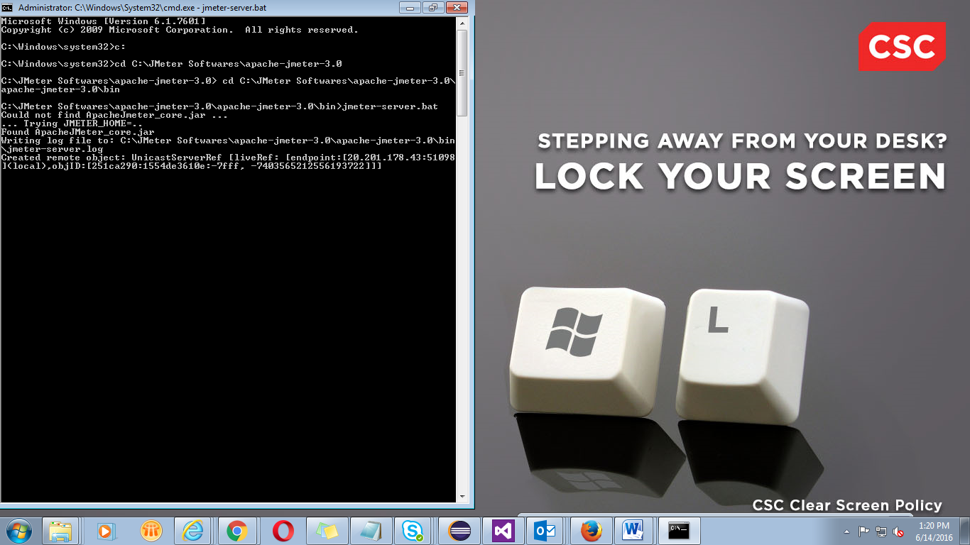

Start JMeter In Command Line Mode:
- Assumption: Apache J-Meter tool binaries are present at following path:
“D:\apache-jmeter-3.0\apache-jmeter-3.0” where “D:\apache-jmeter-3.0” is folder path

- Open command line dialog as administrator→Type the following commands to run J-Meter in Command line mode:

- Execute following command to navigate to drive where J-Meter tool binaries are present. “<drive name>:” Here following command was given: “D:”

- Execute following command: “cd <jmeter.bat file path>jmeter.bat”. Here following command was given: “D:\apache-jmeter-3.0\apache-jmeter-3.0\bin\jmeter.bat". Please refer the screenshot below:

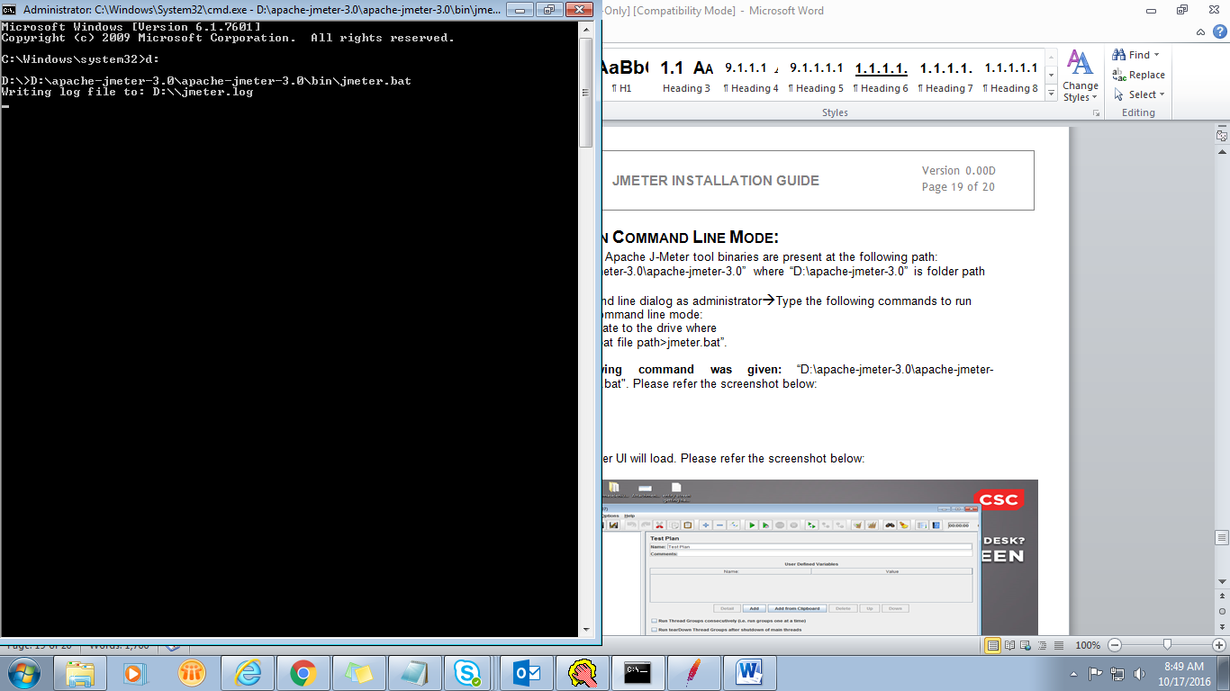

- After that Apace JMeter UI will load. Please refer the screenshot below:

- To execute J-Meter in non-GUI mode from command line following options need to be provided: -n (indicative for non GUI mode) –t (indicative that next value provide is test name to be executed)
- For instance: “D:\apache-jmeter-3.0\apache-jmeter-3.0\bin\jmeter.bat –n –t TC_001.jmx will execute TC_001 in non GUI mode (that is without rendering any GUI for J-Meter)

Required JMeter Property Changes:

Property File Changes:

- Navigate to the following path: "D:\apache-jmeter-3.0\apache-jmeter-3.0\bin\jmeter.properties"
- Right click on “jmeter.properties” file and select “Edit with Notepad++” option→Navigate to “Miscellaneous configuration” section. Uncomment and change the following property value to true:
- “CookieManager.save.cookies=true”
When set to true following property enables J-Meter to save cookies as variables which can be used to pre/post process or modify the samples.
- Navigate to “Results file configuration” section of “jmeter.properties” file. Please check values of below mentioned properties are as stated below, if not please change the property values to as stated below:

- jmeter.save.saveservice.output_format=csv
- jmeter.save.saveservice.assertion_results_failure_message=true
- jmeter.save.saveservice.assertion_results=none
- jmeter.save.saveservice.data_type=true
- jmeter.save.saveservice.label=true
- jmeter.save.saveservice.response_code=true
- jmeter.save.saveservice.response_data=false
- jmeter.save.saveservice.response_data.on_error=false
- jmeter.save.saveservice.response_message=true
- jmeter.save.saveservice.successful=true
- jmeter.save.saveservice.thread_name=true
- jmeter.save.saveservice.time=true
- jmeter.save.saveservice.subresults=true
- jmeter.save.saveservice.assertions=true
- jmeter.save.saveservice.latency=true
- jmeter.save.saveservice.connect_time=false
- jmeter.save.saveservice.samplerData=false
- jmeter.save.saveservice.responseHeaders=false
- jmeter.save.saveservice.requestHeaders=false
- jmeter.save.saveservice.encoding=false
- jmeter.save.saveservice.bytes=true
- jmeter.save.saveservice.url=false
- jmeter.save.saveservice.filename=false
- jmeter.save.saveservice.hostname=false
- jmeter.save.saveservice.thread_counts=true
- jmeter.save.saveservice.sample_count=false
- jmeter.save.saveservice.idle_time=true
- jmeter.save.saveservice.timestamp_format=ms
- jmeter.save.saveservice.timestamp_format=yyyy/MM/dd HH:mm:ss.SSS
- jmeter.save.saveservice.default_delimiter=,
- jmeter.save.saveservice.default_delimiter=\t
- jmeter.save.saveservice.print_field_names=true
- jmeter.save.saveservice.autoflush=false

- To avoid re-application of modifications when upgrading JMeter
- Property modification should be done in:
"D:\apache-jmeter-3.0\apache-jmeter-3.0\bin\user.properties" file
- Copy the property you want to modify to “user.properties” from “jmeter.properties”
- Change its value there

Batch File Changes:

- Navigate to path "D:\apache-jmeter-3.0\apache-jmeter-3.0\bin\jmeter.bat". Right click on “jmeter.bat” file and select “Edit with Notepad++” option→Edit the following code line: “set HEAP=-Xms512m -Xmx512m” to “set HEAP=-Xms512m -Xmx4096m”

- Following property change increases the heap size memory allocation to 4GB from 512 MB thus reducing the chances of Java “OutOfMemory” exception, specially while running large load tests

Revision History Of The Work Product:
# | Date | Version # | Section Changed | Details of changes made | Approved By
1 | 14th June 2016 | 0.00 D |  | 1. Created
2 | 14th Oct 2016 | 0.01 D |  | - Added steps to start J-Meter in Command Line Mode
3 | 17th Oct 2016 | 0.02 D |  | - Added steps for Required J-Meter Property Changes

